CREATE TABLES –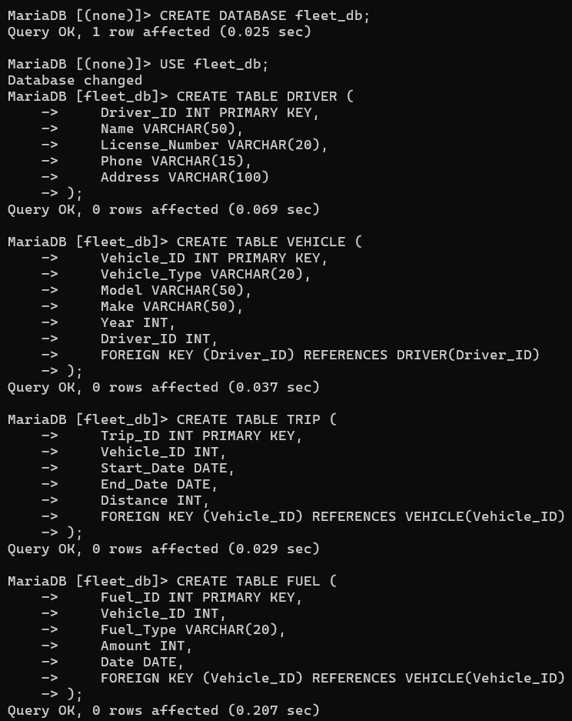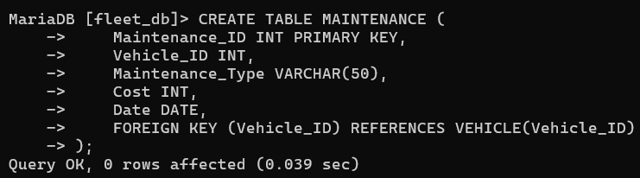

INSERTING VALUES IN TABLES –

INSERTING VALUES IN DRIVER TABLES: 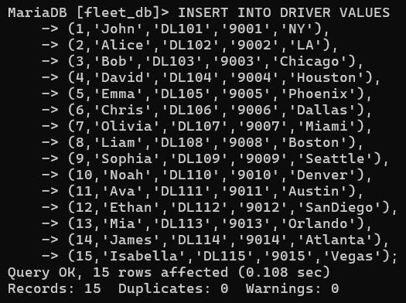
INSERTING VALUES IN VEHICLE VALUES:
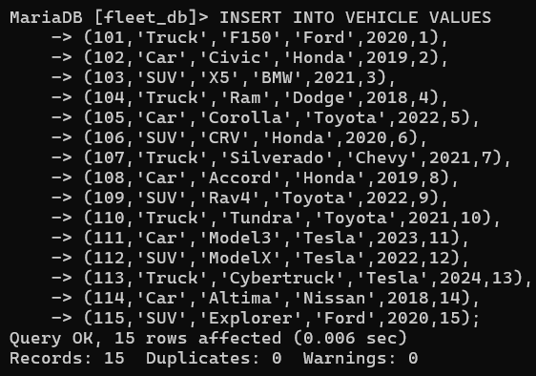
INSERTING VALUES IN TRIP VALUES: 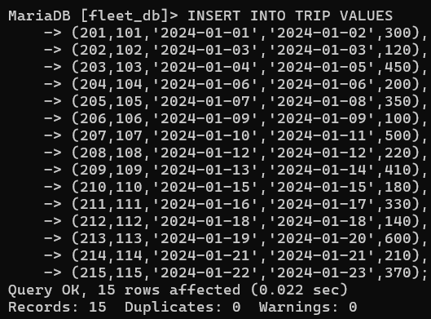
INSERTING VALUES IN FUEL VALUES: 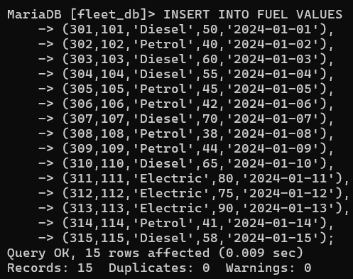
INSERTING VALUES IN MAINTENANCE VALUES: 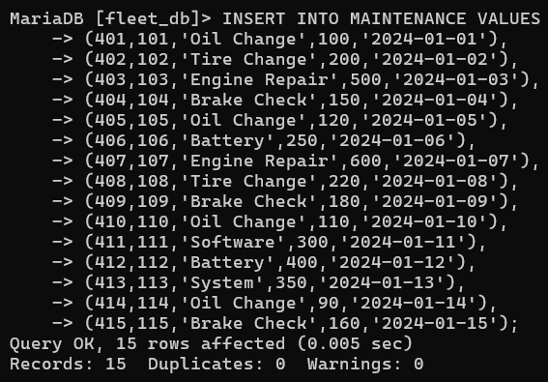
SHOW AND DESCRIBE DRIVER TABLES:
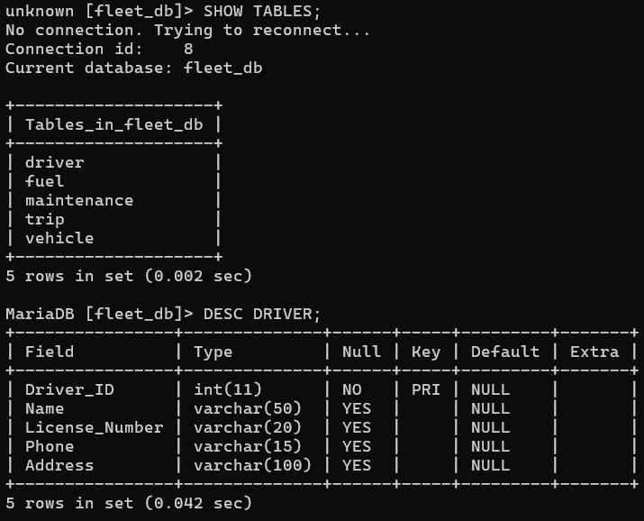
SELECTING DATA FROM DRIVER: 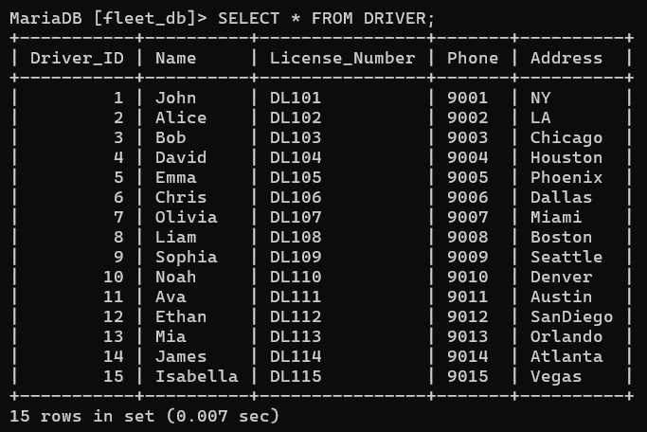
SELECTING DATA FROM FUEL: 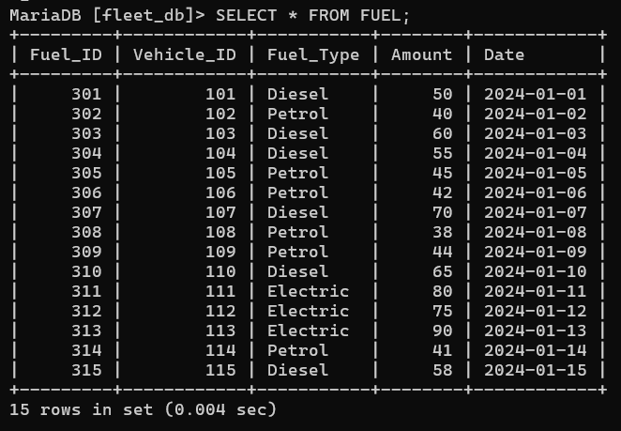
SELECTING DATA FROM MAINTENANCE: 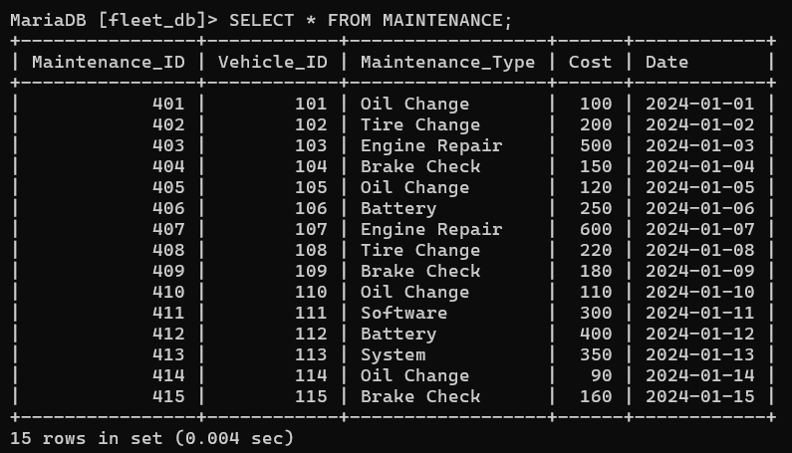
SELECTING DATA FROM TRIP: 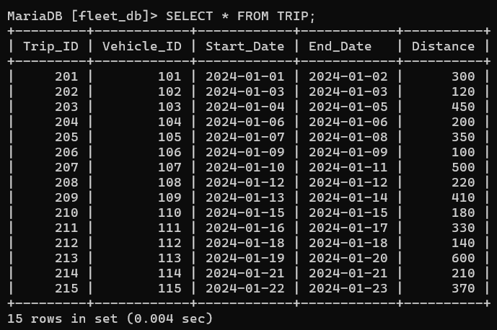

SELECTING DATA FROM VEHICLE: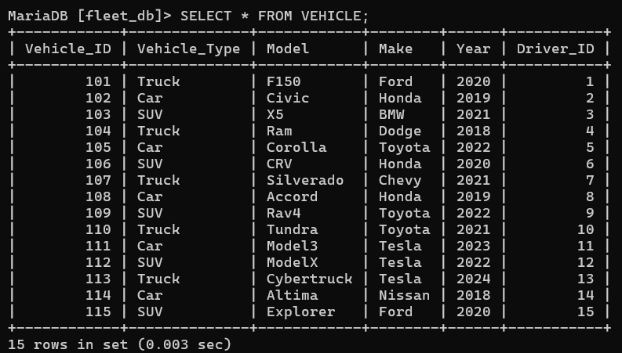

QUERIES-
- SHOWING THE NAME OF DRIVER
SELECT NAME FROM DRIVER;
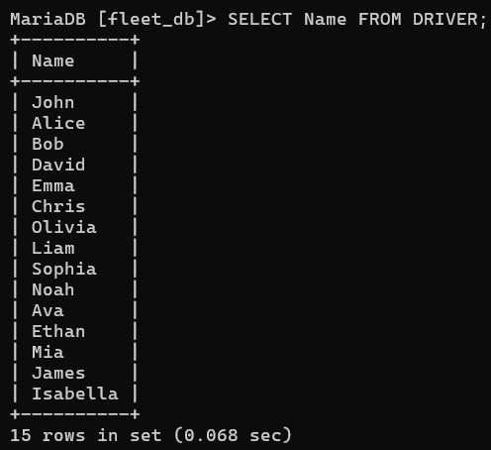

2)SHOWING MODEL MAKE FROM VEHICLE.
SELECT MODEL , MAKE FROM VEHICLE;
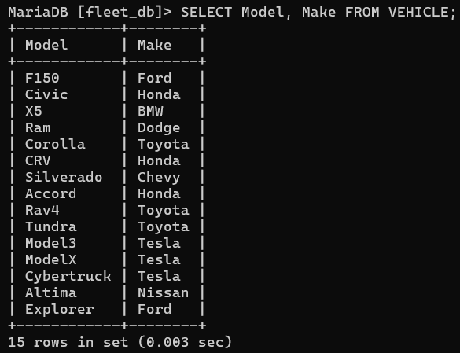

3)SHOWING VEHICLE TYPE.
SELECT DISTINCT VEHICLE_TYPE FROM VEHICLE;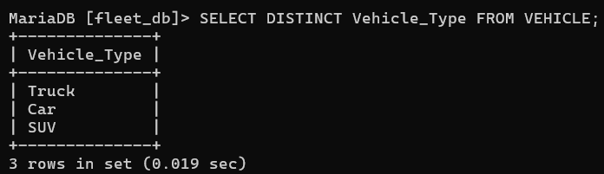

4)SHOWING NAME PHONE NUMBER OF DRIVER.
SELECT NAME, PHONE FROM DRIVER; 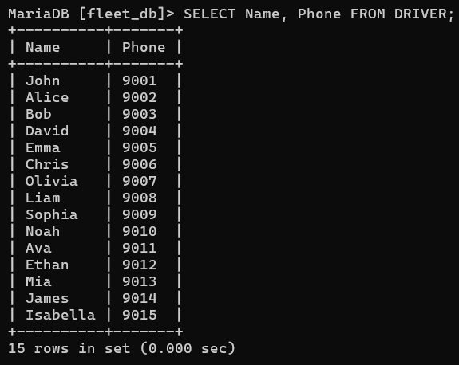

5)SHOWING VEHICLE YEAR MORE THEN 2020.
SELECT * FROM VEHICLE WHERE YEAR >2020;
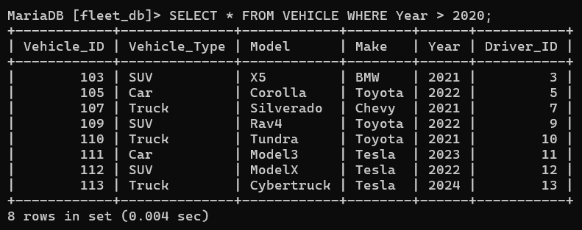

6)SHOWING TRIP DISTANCE MORE THEN 300.
SELECT * FROM TRIP WHERE DISTANCE > 300;
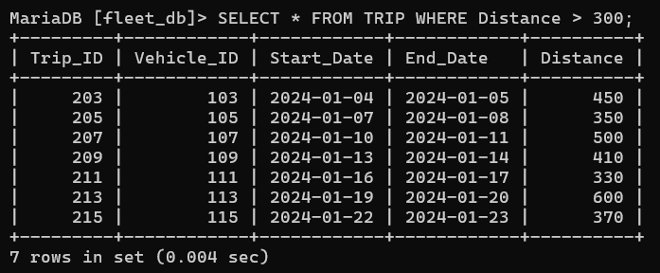
7)SHOWING VEHICLE’S FUEL TYPE IS DIESEL.
SELECT * FROM FUEL WHERE FUEL_TYPE = ‘DIESEL’;
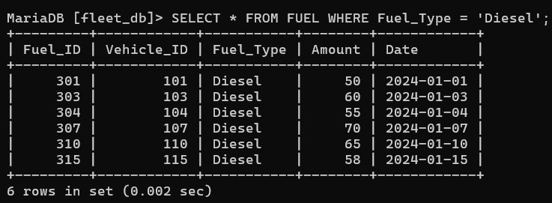

8)SHOWING MAINTENANCE COST MORE THEN 200.
SELECT * FROM MAINTENANCE WHERE COST > 200;
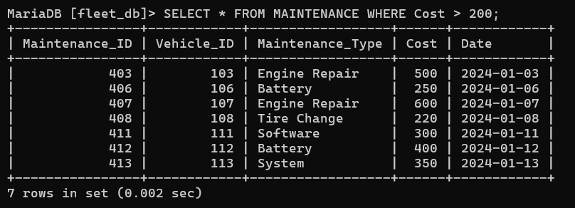
9)SHOWING DRIVER ADDRESS IS NY.
SELECT * FROM DRIVER WHERE ADDRESS = ‘NY’;
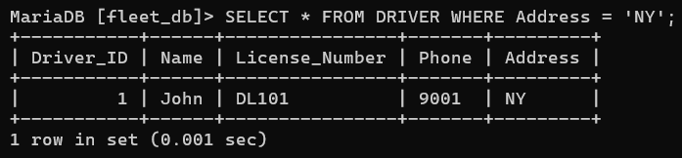

10)SHOWING AVERAGE DISTANCE FROM TRIP.
SELECT AVG(DISTANCE) FROM TRIP;
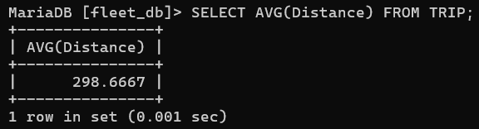

11)SHOWING MAXIMUM COST OF MAINTENANCE.
SELECT MAX(COST) FROM MAINTENANCE;
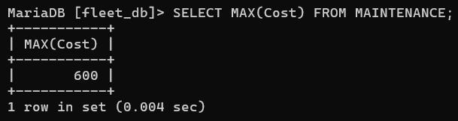

12)DESCRIBE THE DISTANCE OF THE TRIP.
SELECT * FROM TRIP ORDER BY DISTANCE DESC;
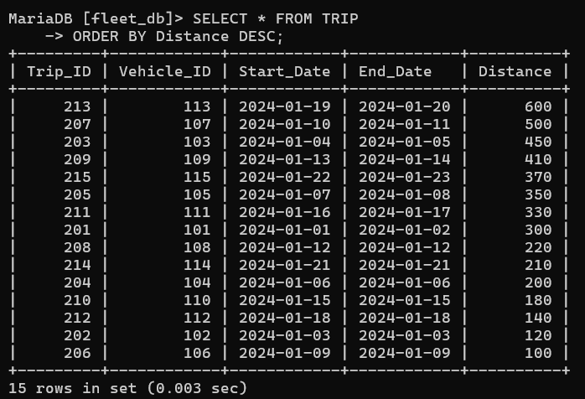
13)SHOWING VEHICLE_ID AND TOTAL AMOUNT OF FUEL.
SELECT VEHICLE_ID, SUM(AMOUNT) FROM FUEL GROUP BY VEHICLE_ID;
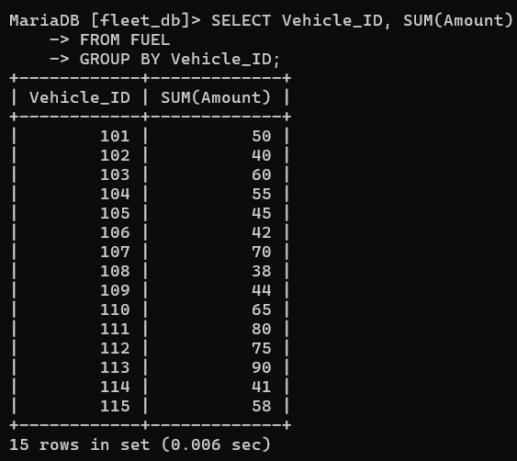
14)SHOWING FUEL TYPE WITH TOTAL AMOUNT OF FUEL.
SELECT FUEL_TYPE , SUM (AMOUNT) FROM FUEL GROUP BY FUEL_TYPE;

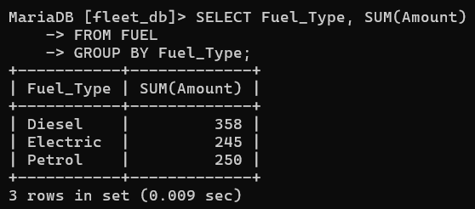
15) SHOWING FUEL TPE AND MODEL.SELECT F.FUEL_TYPE, V.MODEL FROM FUEL F JOIN VEHICLE V ON F.VEHICLE_ID = V.VEHICLE_ID;
